(Approx. 1,587 words)

Windows Q & A April 2012
By Mary Phillips, Secretary, Icon Users Group, MO
April 2011 issue, The ICON-Newsletter of the Interactive Computer Owners Network
www.iconusersgroup.com
mary@iconusersgroup.org

Q1. What are the differences between Data Backup, System Restore, Disk Image, System Recovery Disc and System Repair Disk?

A1. Data Backup – Making copies of personal data files that may be used to restore the originals in case of data loss or simply to restore data from an earlier time. Backed up folders/files may include Documents, Pictures, Music, Videos, and/or Downloads – files it could be difficult or impossible to replace.

Options for backing up your data depends on the hardware you have available and the amount of information you need to back up – DVD’s, flash drives, external hard drives or online storage in the “cloud”. An external hard drive may provide the most flexibility because they are relatively inexpensive and can hold large amounts of information.

In Windows 7, in the Control Panel, click on Backup and Restore. In this window, you have four main options: Backup, Restore from the Backup, Create a System Image and Create a System Repair Disc.
1. Choose Set up Backup and click on the Backup Destination. In the picture below there are two choices: DVD RW Drive (D:) and My Book (K:). Click Next.

2. What do you want to back up? If you choose Let Windows choose, Window will back up data files saved in Libraries, on the desktop, and in default Windows folders.
It will also create a system image (described later) which can be used to restore your operating system AND data files in the case that your computer quits working.

Backup for my computer took approximately 2530 minutes, was 49 GB and was saved in a folder automatically Mary-PC. (See below)

Backups are created in sets; the folder “set” in Mary-PC folder, is named Backup Files 2012-03-20 110818. It contains 8 compressed folders that can be opened and individual
Files retrieved.

System Restore involves Windows system files, programs, registry settings, and most drivers. It does nothing with personal files, such as e-mail, documents, or photos.
Windows creates what are called Restore Points or “date and time specific snapshots” automatically unless for some specific reason the feature has been turned off. Users can also create restore points manually. The benefit of a Restore point is that it allows the user to “roll back” the system settings and installed programs to a date before a problem existed. Sometimes an update will create a problem or a piece of malware makes things go haywire. Those are good times to use System Restore. A system restore can also be undone if it doesn’t fix a problem.

System Restore automatically recommends the most recent restore point created before a significant change, such as installing a program. However, you can and choose from a list of restore points if you check in the box beside Show more restore points (Win 7).
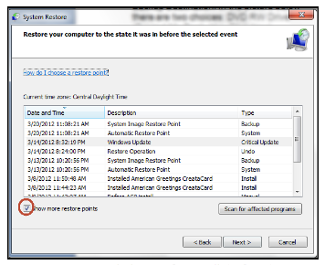
In Windows 7, go to the Control Panel, click on Backup and Restore, click on the link recover system settings to select a restore point. Then you’ll see the window below.

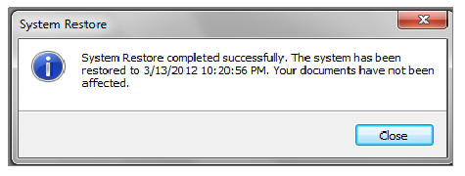
To create a restore point manually in Windows 7, do the following:
1. In the Control Panel, click on System—System Protection. At the bottom of the window, click on the Create button.
2. Type a description, like “Before Sample program installation”. Click Create and
System Protection creates the restore point.

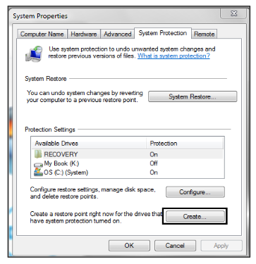

In Windows XP follow this path: All Programs—Accessories—System Tools—System Restore.
1. Choose whether you want to 1) Restore the computer to an earlier time, or 2) Create a restore point. Click Next.
2. If you chose Restore a computer to an earlier date, on the calendar, the dates in bold are the dates that restore points were created. Click on the preferred date. Click Next.
3. If you chose Create a Restore Point, you then will need to give it a description. Click Next and the restore point will be created.

System Image -- A system image is an exact copy of a drive. By default, a system image includes the drives required for Windows to run. It also includes Windows and your system settings, programs, and files. You can use a system image to restore the contents of your computer if your hard disk or computer ever stops working. When you restore your computer from a system image, it's a complete restoration—you can't choose individual items to restore, and all of your current programs, system settings, and files are returned to the condition it was in when the System Image was created.

Although this type of backup includes your personal files, it is recommended that you back up your files regularly using Windows Backup so that you can restore individual files and folders as needed. When you set up Windows Backup, you can let Windows choose what to back up, which will include a system image, or you can select the items that you want to back up and whether you want to include a system image.

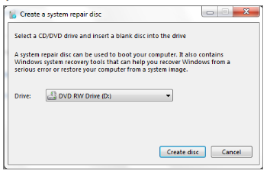

You will need to create the System Repair Disc to use with the System Image disks.

System Recovery Discs – Return your computer to its original purchased condition. The manufacturer most often provides an option to create these disks the first time you turn on your computer. When you click on Create System Recovery Disks, you need to have CDs or DVDs ready.

You will end up with a series of CDs (a bunch!) or several DVDs (mine took two DVDs.) These disks are created from a special partition on the hard drive and usually can be created only once. However, the manufacturers are happy to sell you a set of Recovery disks or the technology store where you buy your computer will offer to create the recovery disks for you.

On the good side, System Recovery Discs come in handy in an emergency. Just feed your PC the System Recovery Discs, and your PC regresses into the same machine you originally brought home from the store.

On the bad side, however, you’ll lose every program, photo, and file you’ve stored on that PC since you bought it. System Recovery Discs only care about returning your PC to its original, first purchased, condition. Everything else is swept away. So you’d need to reinstall and get updates for every program added since you bought the computer.

System Repair Disc – In the Backup and Restore window of Windows 7, Microsoft built a System Repair Disc option that works quite differently from the PC manufacturer’s System Recovery Discs. (Creating the System Repair Disc takes only a few minutes and it only takes up 142MB of space so a CD will work fine. Label the CD as Repair Disc Windows 7 32 or 64 bit.)

When your PC no longer runs properly, insert Windows 7′s System Repair Disc into your PC, and press the On switch. Instead of returning your PC to its original condition, the System Repair Disc offers several menu options: Startup Repair. This examines Windows 7′s most integral files, then repairs any missing or damaged files that may be keeping Windows 7 from starting.

System Restore. Just like the normal System Restore option, this restores your PC’s system files to an earlier point in time, hopefully fixing any recently developed problems. It doesn’t affect your personal files, like e-mail, documents, or photos. There’s one key difference between this version of System Restore, though: When run from the System Repair Disc menu, System Restore doesn’t have an undo option. (However, you can run System Restore again and choose a different restore point, if one exists.)

System Image Recovery. If you’ve created a “System Image” in Windows 7′s backup options, this option returns your PC to the condition it was in when you made the System Image backup. It’s truly a lifesaver, but only if you create System Image disks
regularly.

Windows Memory Diagnostic Tool. Designed to ferret out hardware problems, this examines your PC’s memory for errors.

Command Prompt. This lets techies dig deep into Windows’ internal crevices. It’s designed for people comfortable typing in commands, not moving around a mouse.

In short, the System Recovery discs return your PC to the state it was when first purchased, scrapping all your data while along the way. The System Repair disc, by contrast, offers tools to help bring your ailing PC back to life, keeping all your valuable files safe.

When in major trouble first try your System Repair, as it may solve your problem. Only use the System Recovery Discs as a last resort, as they wipe out everything you’ve created since buying your PC.

What should I do about System Restore if I get a virus? If you know that your system is infected by a virus, you should temporarily turn off System Restore. Otherwise, the virus could be saved along with other system files in a restore point and reintroduced to your system during a restore operation at a later date.

To turn off System Restore in both Windows 7 and XP, press and hold the Windows key and press the Break key to bring up the System Properties dialog box. Then, click on the System Restore tab, select the Turn Off System Restore check box, and click OK. In
Win 7, as soon as you do, you'll see a confirmation dialog box warning you that turning off System Restore will delete all existing restore points. Click Yes to continue.

